Testing Approach
The application was tested using manual functional testing. The main features of the system were checked, including patient information, lab results, biomarkers, CMAS history, disease trend overview, and the patient summary report. Invalid input was also tested to verify that the system handles user mistakes safely without crashing. The expected results were compared with the actual results, and screenshots were collected as evidence.

A) Issues Found During Testing
During testing, a few small issues were identified. At first, some dates were not displayed in a consistent format, and the latest biomarker values were not always selected correctly in all output screens. These issues did not affect the core functionality of the system, but they reduced readability and consistency.
B) Improvements Made
After testing, several improvements were made to the application. Date formatting was improved in the output screens, CMAS dates were standardized, and the logic for selecting the latest biomarker values was corrected. In addition, the formatting of lab results and reports was improved to make the output clearer and more professional.

The following table shows the main tests performed on the system.

Test ID | Feature | Description | Input | Expected Result | Actual Result | Status | Evidence
T1 | Application startup | Check application startup | Run Main.java | Program starts, loads data, and shows menu | Program started, loaded data, and showed menu | Pass | Figure 1
T2 | Patient information | Check patient information screen | Enter 1 | Patient ID, name, and diagnosis are shown | Patient ID, name, and diagnosis were shown correctly | Pass | Figure 2
T3 | Lab results | Check lab results screen | Enter 2 | Lab results are grouped and show name, unit, value, and date | Grouped lab results were shown correctly | Pass | Figure 3,4
T4 | Biomarkers | Check biomarker overview | Enter 3 | Biomarkers are shown with date, value, and unit | CXCL10 and Galectin-9 were shown correctly | Pass | Figure 5
T5 | CMAS history | Check CMAS history screen | Enter 4 | CMAS dates, scores, bars, and summary are shown | CMAS history and summary were shown correctly | Pass | Figure  6, 7
T6 | Disease trend overview | Check disease trend screen | Enter 5 | Trend summary and latest biomarkers are shown | Trend and latest biomarkers were shown correctly | Pass | Figure 8
T7 | Patient summary report | Check patient report | Enter 6 | Report shows latest CMAS, biomarkers, measurements, and status | Report was generated correctly with all required data | Pass | Figure 9
T8 | Invalid numeric input | Check invalid menu number | Enter 8 | Error message is shown, no crash | Error message was shown and program continued. | Pass | Figure 10
T9 | Invalid text input | Check text input handling | Enter A | Error message is shown, no crash | Error message was shown and program continued | Pass | Figure 11
T10 | Date formatting | Check date formatting in outputs | Enter 2, 3, and 4 | Dates are readable and consistent | Dates were displayed in readable format | Pass | Figure 12, 13 and 14
Figure 1: Main menu after successful data loading
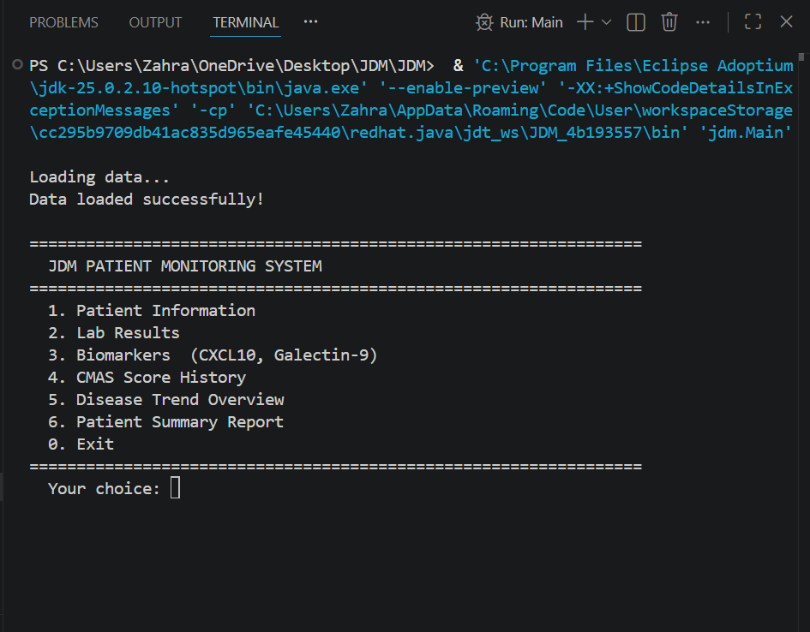

Figure 2: Patient information screen
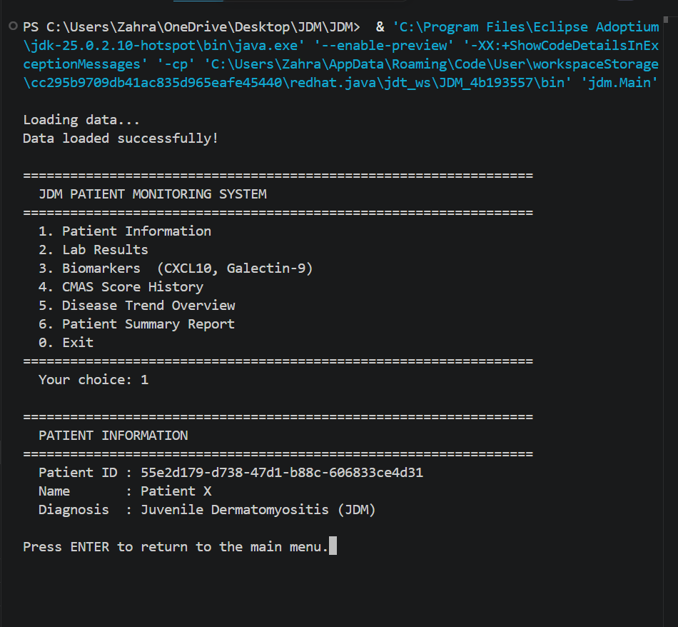
Figure 3, 4: Grouped lab results
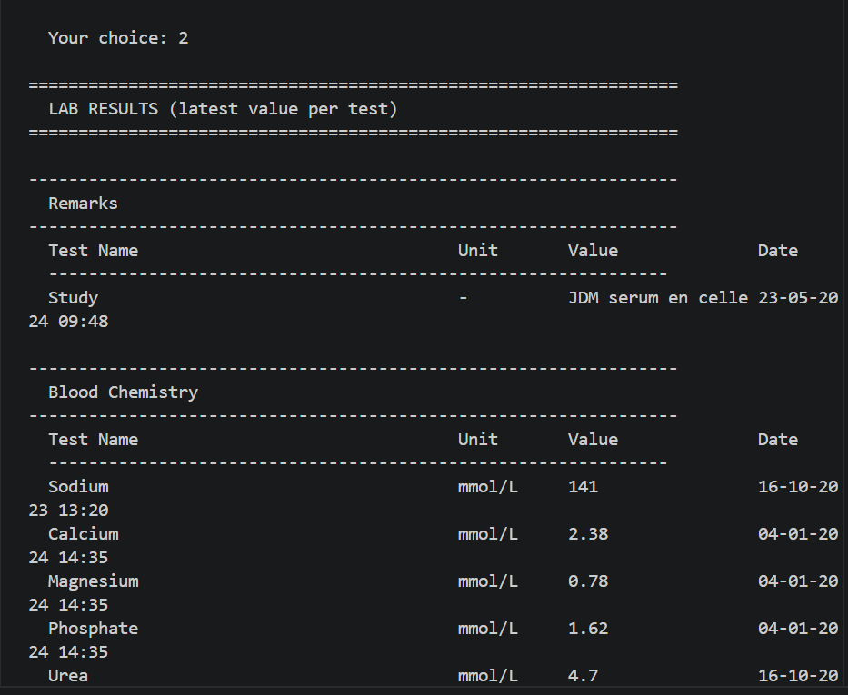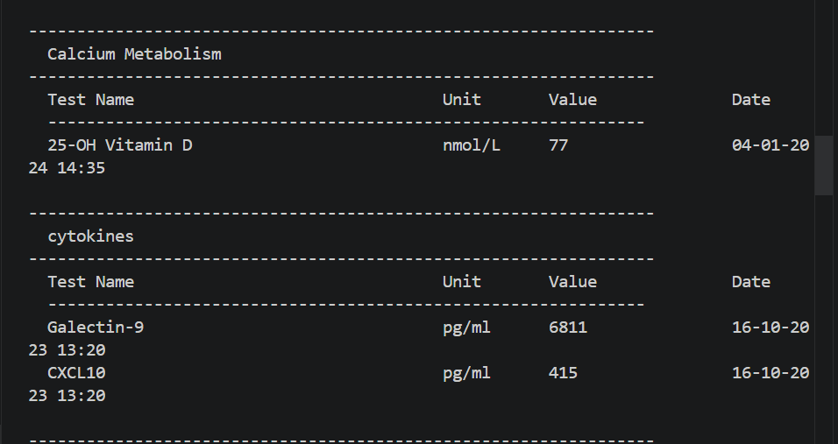

Figure 5: Biomarker overview 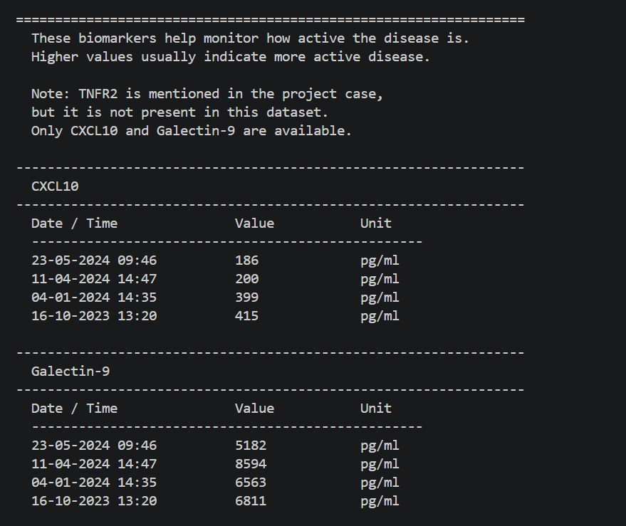

Figure 6, 7: CMAS score history
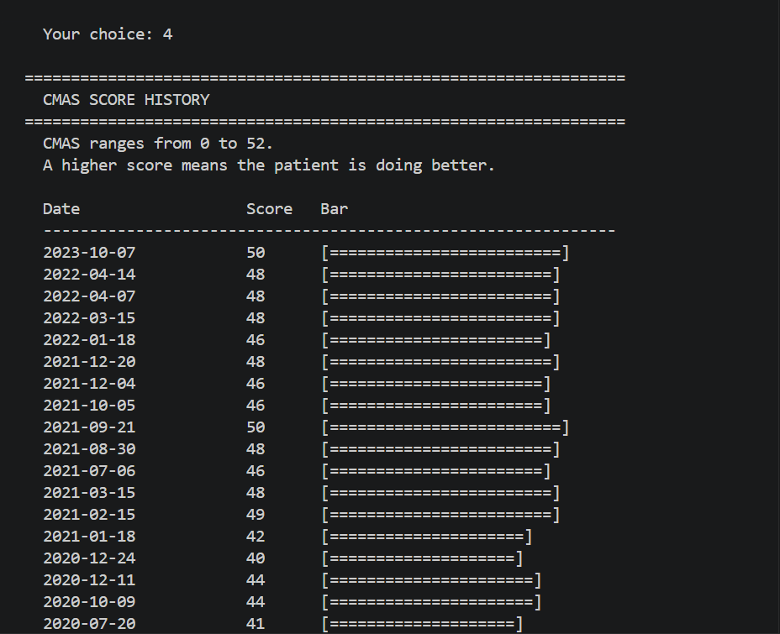
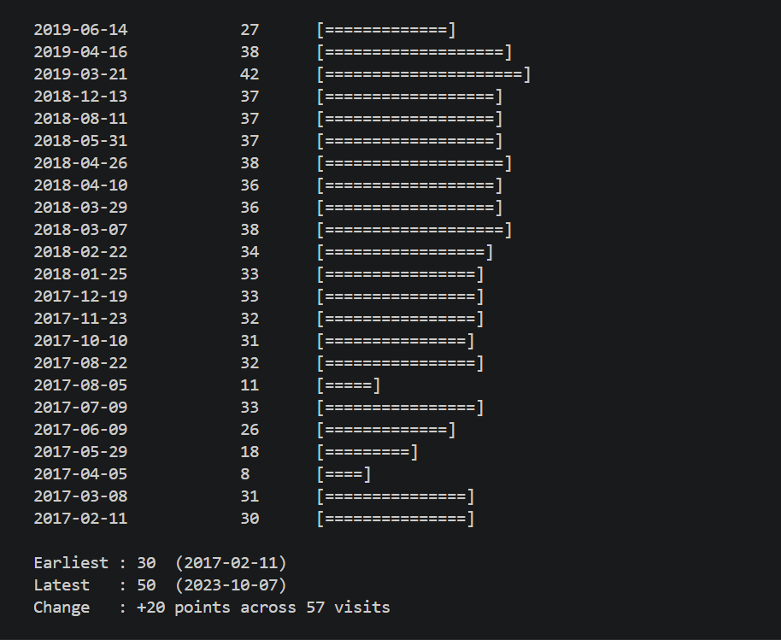

Figure 8: Disease trend overview 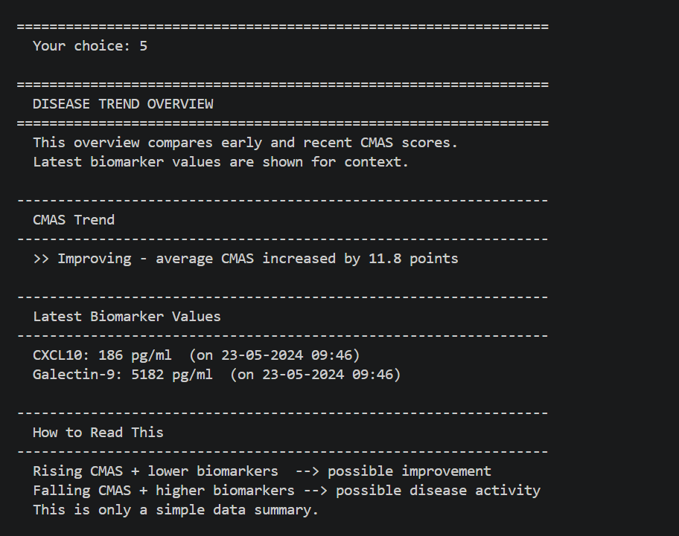
Figure 9: Patient summary report 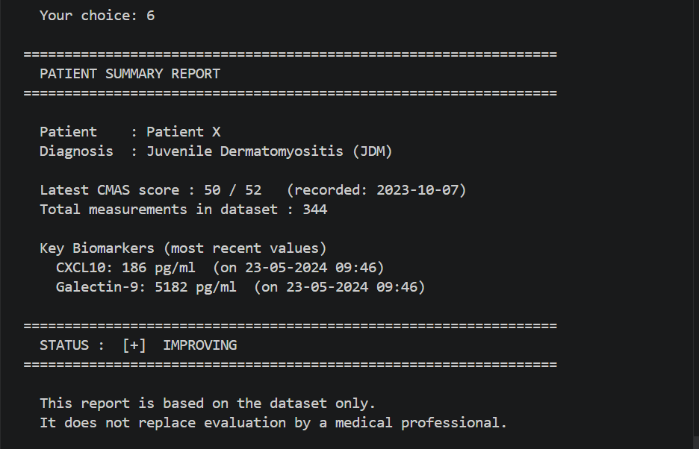
Figure 10, 11: Invalid input handling

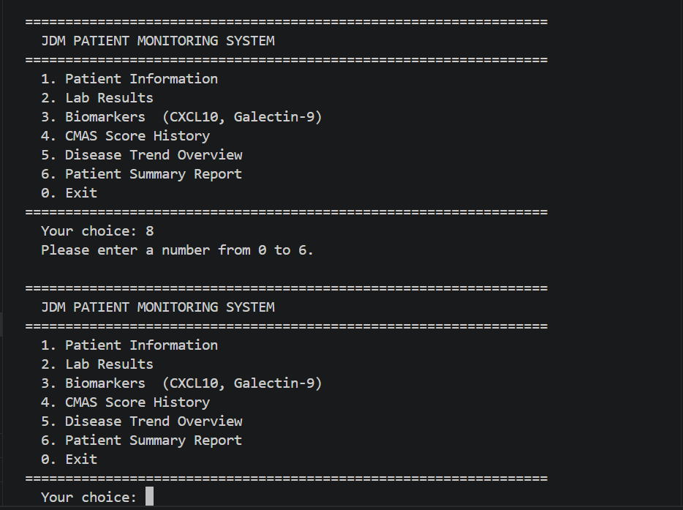
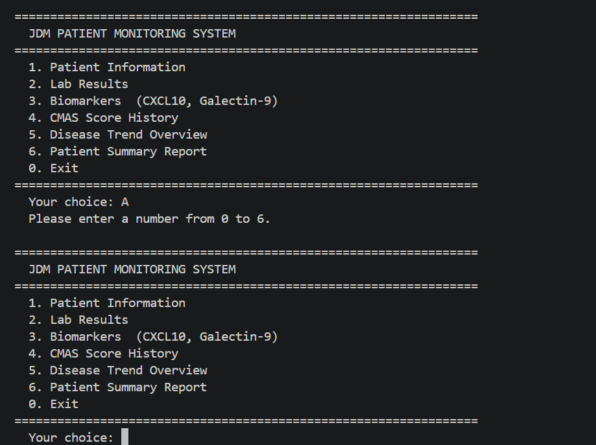

Figure 12, 13 and 14: Dates were tested and displayed correctly
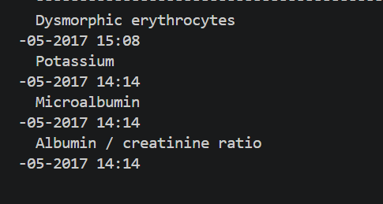
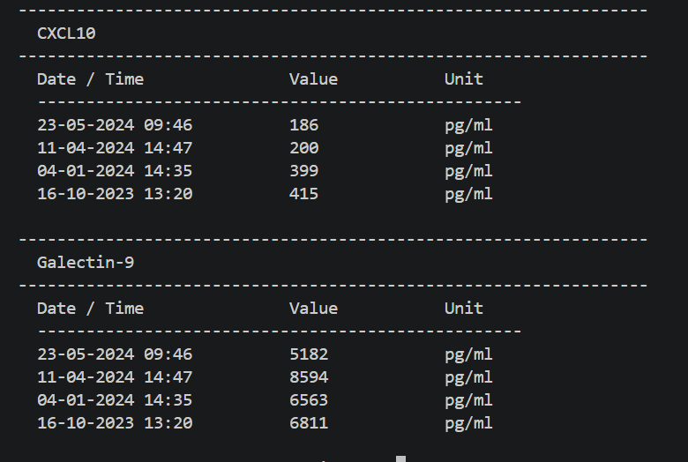
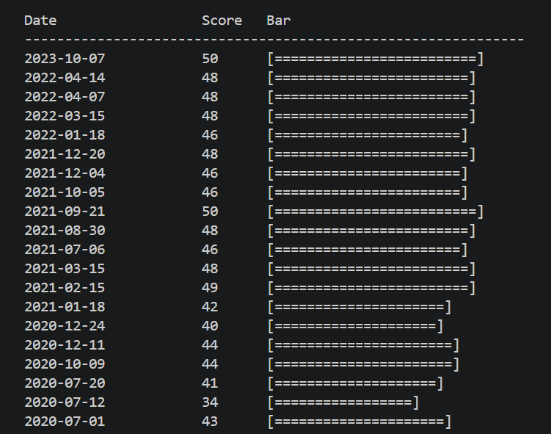
Testing Conclusion
The testing results show that the main features of the application work correctly and that the system handles invalid input safely. Overall, the application meets the functional requirements defined for this project and provides a stable and readable console-based solution for monitoring the JDM dataset.

